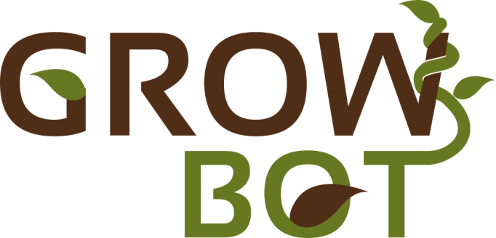

**Towards a new generation of plant-inspired growing artefacts**

Grant Agreement No. 824074



**GrowBot – 2nd Call for Ideas**

**(Call for Proposals, Guidelines and Rules for Participation)**

**About GrowBot**

GrowBot is a European project funded under the Future and Emerging Technologies (FET) programme, specifically FET-Proactive, of the EU framework programme for research and innovation (Horizon 2020).

GrowBot proposes a disruptively new paradigm of movement in robotics inspired by the moving-by-growing abilities of climbing plants.

Plants are still a quite unexplored model in robotics and ICT technologies, as their sessile nature leads to think that they do not move. Instead, they move greatly, on a different time scale, purposively, effectively and efficiently. To move from one point to another, plants must grow and continuously adapt their body to the external environmental conditions. This continuous growth is particularly evident in climbing plants.

The GrowBot objective is to develop low-mass and low-volume robots capable of anchoring themselves, negotiating voids, and more generally climbing, where current climbing robots based on wheels, legs, or rails would get stuck or fall.

GrowBot is based on a strongly interdisciplinary character and can open the way for a new technological paradigm around the concept of growing robots, fostering a European innovation eco-system for several high-tech sectors.

More information about GrowBot project can be found here: [www.growbot.eu](http://www.growbot.eu)

The current document is about the GrowBot – 2nd Call for ideas.

**GrowBot – 2nd Call for Ideas**

The GrowBot consortium is promoting initiatives that aim to enlarge and enrich the technological and plant science communities for developing bioinspired materials and robotics. In this initiative, we wish to foster new and creative research thinking, primarily for young researchers, designers, artists, who are motivated to work in scientific fields. The project has planned to launch two calls for ideas in the form of prizes (in line with the conditions set out in general Annex K) for performing selected activities at the European level. These calls target scientific topics that are relevant for GrowBot project, yet they do not represent pre-defined core activities of partners.

This second call for ideas is seeking for proposals in the following topic:

* ***Development of an artistic version of a plant-inspired growing robot***

One of the missions of the GrowBot project is to share a new vision of both plant kingdom and bioinspired robotic technologies, by educating people to better understand the functionalities of real plants and the potentialities of technologies inspired by these natural models for future environmental sustainability.

For this objective, it is of major importance the use of new design approaches that merges engineering functionalities, biological principles, with an artistic footprint. The goal of this call is the realization of an artistic version of a plant-inspired growing robot, that can be a graphical or physical representation, and that can be used for showcase/demonstration of biological principles, plants’ abilities and associated engineering solutions. Candidates should address this challenge by considering all potential options and methods; improvements over current approaches are strongly encouraged. Suggestions of new or unconventional approaches which will be more than welcome.

**Keywords**: *plant-inspired robots, growing robots, engineering design, arts and technology*

**GrowBot – 2nd Call for Ideas information**

**Project full name:** GrowBot - Towards a new generation of plant-inspired growing artefacts

**Grant Agreement:** 824074 (H2020-FETPROACT-2018-01)

**Call title:** GrowBot – 2nd Call for Ideas

**Amount of the prize:** EUR 30k

**Conditions for participation:** Young researchers (max 35 years)

**Language of the proposal:** English

**Proposal submission:** Online submission

**Call opening:** October 1st, 2022

**Call deadline:** November 30th, 2022 at 17:00h CET (Brussels time)

**Evaluation of proposals:** December 1st – 19th, 2022

**Winner nomination:** December 20th, 2022

**Research activities:** 1st February – June 30st, 2023

**Proposal Template:** proposals must be submitted using the provided template (in Word format)

**Proposal features:** 3-page proposal (including general idea, a detailed 5-month project workplan, and expected results)

**Added documents:** Proposer CV

**Contact:** info@growbot.eu

**Web address for further information:** <https://growbot.eu/project/openings/second-call-for-ideas>

The proposals will be evaluated by a commission composed of the GrowBot members of the Scientific and Management Board (SMB), the Innovation Management Board (IMB), and the Advisory Board on the base of novelty, feasibility, proposed CV and coherence with the GrowBot objectives.

The winner of the call for ideas will start after 2 months from the end of the call and he/she will be hosted for a 5-month period at one of the institutions of the GrowBot consortium.

The prize (EUR 30k) will be paid to the host institution appointed by the candidate by bank transfer.

**Proposal Template**

The applicants must use the proposal template available at <https://growbot.eu/project/openings/second-call-for-ideas>. In the document there will be instructions specifying the type of information expected per section. Each section should not exceed the maximum number of words indicated. Applicants are solely responsible for completing all required fields in the template according to the instructions.

The proposers must apply online at <https://growbot.eu/project/openings/second-call-for-ideas>. If you discover an error in your proposal, and provided that the call deadline has not passed, you may submit a new version. Only the last version received before the call deadline will be considered in the evaluation. Proposals must be received by the closing time and date of the call. Late proposals, or proposals submitted in any other way than through the online submission form will not be evaluated.

**Letter of Commitment Template**

The proposers must use the letter of commitment template available at <https://growbot.eu/project/openings/second-call-for-ideas>. In the document, the chosen host institution will confirm its intention to sign a supplementary agreement with the candidate in which the listed obligations will be addressed should the proposal be selected.

**Evaluation criteria**

Each proposal will be evaluated in accordance with the following criteria:

* RESEARCH SKILLS (max 30 points)
  + Background and professional experience (max 15 points)
  + Publications (max 15 points)
* PROPOSAL PROJECT (max 50 points)
  + Impact (max 15 points)
  + Novelty (max 15 points)
  + Feasibility (max 20 points)
* PERSONAL SKILLS (max 20 points)
  + Team working (max 4 points)
  + Communication (max 8 points)
  + Motivation (max 8 points)

|  |  |
| --- | --- |
|  | This project has received funding from the European Union’s Horizon 2020 research and innovation programme under grant agreement no. 687860. |